Gloria Dei Lutheran Church

2017 Annual Report

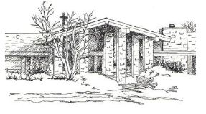

N1230 Seven Corners Road

New Holstein, WI 53061

gloriadeiLC@frontier.com

920-898-5333

*GLORIA DEI LUTHERAN CHURCH*

*“MAKING CRHIST KNOWN”*

N1230 Seven Corners Road

New Holstein, WI 53061

Phone: 920-898-5333

[gloriadeiLC@frontier.com](mailto:gloriadeiLC@frontier.com)

***Table of Contents***

Page

1 Meeting Agenda

2 Current, Appointed & Nominated Positions

3-4 2016 Meeting Minutes

5 President’s Report

5 Council Vice-President’s Report

5 Stewardship Report

6 Parish Ministry Report

6 Capitol Campaign Report

6 Sunday School Report

7 Vacation Bible School Report,

7 Adult Education Report

7 Worship & Music Report

7 Building Report

8 Youth Group Report

8 Mutual Ministry Team Report

8 Outreach Team Report

9 Dinner Theater Report

9 Scrip Report

10-11 2016 Budget Detail

***Gloria Dei Lutheran Church***

***Annual Congregational Meeting***

***January 29th, 2017***

***Agenda***

Welcome – President Joe Janicek

Opening Devotions –

Approval of Minutes

January 28, 2017 Annual Meeting

Discussion and Vote on creating a Constitution/Bylaw change to allow absentee or proxy voting by members in good standing who are unable to attend a special congregational meeting

Budget Presentation and Approval:

Nominations and Elections of Council Members and Officers:

Nomination for a 3-year term to Audit Committee

Appointments to:

Nominating Committee – two non-council members

Synod Assembly – 2 delegates (male & female)- Julie and Darryl Schaefer

Green Bay Conference – 2 delegates (annual mtg)- Pat and Jerry Jensen

Manitowoc Cluster- 2 delegates (1-2 mtgs a year)- Michael Hetzner and Cheryl Heller

Crossways Lutheran Camping Ministry- 2 delegates- Rachel Barrett and youth member

Annual Meeting Fond du Lac Lutheran Home- Rachel Barrett

Closing Prayer:

Adjournment and Lord’s Prayer



**Thank You to Our Council Members Thank You to Audit Committee**

*Members* *at* *Large*: Rachel Barrett Anne Sellen

Jerry Jensen Dean Meyer

Gary Meyer Cheryl Heller

Coleen Allee

Sue Erickson

**Outgoing Council Members Mutual Ministry Team**

Annette Pleshek Andrew Deehr

Charlotte Deehr Annette Pleschek

Jerry Jensen

Gary Meyer

**Special Thanks** **Nominating Committee**

Andrew Deehr—*Youth* *Group* Dianne Fett

Al Fett—*Stewardship* *Team* Mike Hetzner

Raeline Springstroh—*Worship* *& Music*

Dee Langhor—*Memorial* *Fund*

Mike Hetzner—*Outreach* *Team*

Cheryl Heller—*SCRIP*

All members in congregation who helped on *Property Team*

***2017 Statistical Report***

**Baptized Members** **Confirmed Members**

254 203

**Number of Households** **Worship Services**

90 104

**First Communions** *49 Sunday; 45 Wednesday; 4 Lent; 3Advent*

1 *Edward Lemuix, Alex Jeanty, Vincent Janicek 1 Ash Wednesday; 1 Maundy Thursday*

*1 Thanksgiving Eve Ecumenical,*

**Confirmations** *1 Christmas Eve*

1

**Average Weekly Attendance**

**Marriages** Sunday: 32 (49 of 51 Sun. reported)

1 *Andy and Colleen Anderson* Wednesday: 14 (45 of 53 Wed. reported)

**Baptisms** **Members Received**

3 *Savannah Cobble,* *Chelsea Schultz, Gordon* *Janicek* 0

**Burials/Deaths** **Members Removed**

3 *Nora Hetzner, Marilyn Budzein, Barbara Gault* 2

2

***Gloria Dei Lutheran Church—Annual Congregational Annual Meeting Minutes***

**January 29, 2017**

3

**Welcome & Prayer:** President Louie Kolberg

**Call to Order:** 10:30 a.m. Quorum was met with 38 members.

**Opening Devotion:**  Pastor Traci Maass

**Approval of Minutes from January 31, 2016 Annual Meeting:**

Ben Henke motioned to approve minutes, Barb Spiegel seconded, motion carried.

**Approval of By-law Update:**

Discussion and vote on creating a Constitution/Bylaw change to allow absentee or proxy voting by members in good standing who are unable to attend a special congregational meeting. At last special meeting, several people couldn’t attend and were upset that they couldn’t vote. Wayne Zwart motioned to dismiss this, Craig Heller seconded, motion carried.

**2017 Budget Presentation and Approval-Alan Fett:**

Discussion included:

* How income was projected
* Mission Investment requiring a capital pledge drive
* How last year’s budget was covered
* Using money in the roof fund to cover mortgage payments
* Discrepancy between monthly spreadsheet of revenues/expenses for 2016 kept by the treasurer vs. actual annual 2016 budget indicated on the Proposed Budget sheet for 2017
* Need to grow membership or increase giving
* Possibility of having a part-time pastor
* Long process of getting all pieces of usable data together from cottage meetings

Craig Heller motioned to have Council revise 2017 budget as presented, Dick Welsch seconded, motion was questioned as to whether it carried. Further discussion ensued.

Craig revised his motion to include: Have Council revise 2017 budget as presented to align the 2016 revenues/expenses spreadsheet done monthly with the actual annual budget for 2016 indicated on the Proposed Budget sheet for 2017, including the reliance on the special air-conditioning pledge fund and defining the building fund income line for 2017; Dick Welsch seconded; motion defeated.

Mike Hetzner motioned to approve budget as presented, Dianne Fett seconded, motion carried.

Mary Jo motioned to have columns listed on the proposed budget sheet for next year that say proposed 2017, actual 2017, and proposed 2018; Rachel Barrett seconded; motion carried.

**Nominations and Elections of Officers and Chairpersons:**

Louie presented the 2017 Council Nomination Ballot: Five nominations needed (three Council-at-large positions, president, and treasurer). Sue Erickson, Coleen Allee, and Rachel Barrett volunteered to be nominated for the Council-at-large positions. (Annette Pleshek agreed to run for vice-president and Charlotte Deehr for secretary, leaving their Council-at-large positions vacated.) Joe Janicek nominated himself for president. Mary Jo Muellenbach volunteered for the treasurer position.

Nominations—2017 Council Officers (2-Year Terms) –

* President: Joe Janicek
* Vice-President: Annette Pleshek (in second year of 2-year term)
* Secretary: Charlotte Deehr (in second year of 2-year term)
* Treasurer: Mary Jo Muellenbach

Nominations—2017 Council-at-Large Positions (2-Year Terms):

* Sue Erickson
* Coleen Allee
* Rachel Barrett

(Gary Meyer and Jerry Jensen remain with one more year left.)

Al Fett motioned to close nominations, Cheryl Heller seconded, motion carried.

Dianne Fett motioned to approve all nominations, Pat Jensen seconded, motion carried.

Voted onto 2017 Council: Joe Janicek, Mary Jo Muellenbach, Sue Erickson, Coleen Allee, and Rachel Barrett.

**Nomination for a 3-year term to Audit Committee:**

* Anne Sellen has 1 year left.
* Dean Meyer has 2 years left.
* Cheryl Heller was appointed to 3-year term.

**Appointments to:**

* Nominating Committee – 2 non-Council members:

Dianne Fett and Mike Hetzner

* Synod Assembly – 2 delegates (male & female) – May 19 and 20, 2017:

Julie and Darryl Schaefer

* Green Bay Conference (annual meeting) – 2 delegates – Saturday, February 11, 2017, 10 a.m.-2 p.m.:

Pat and Jerry Jensen

* Manitowoc Cluster – 2 delegates (1-2 meetings/year):

Michael Hetzner and Cheryl Heller

* Crossways Lutheran Camping Ministry – 2 delegates – March 4, 2017, 10 a.m.-1 p.m. at St. Mark’s Lutheran Church, Neenah:

Rachel Barrett and youth member

* Annual Meeting – Fond du Lac Lutheran Home – Tuesday, April 25, 2017, 7 p.m.:

Rachel Barrett

Louie thanked everyone for attending; Dean Meyer thanked outgoing Council members.

**Closing Prayer:** Pastor Traci

Andrew Deehr motioned to adjourn, Coleen Allee seconded, motion approved.

Respectfully submitted,

Jayne Meyer, Council Secretary

4

***President’s Report***

With our annual meeting coming up soon, I am encouraging everyone to make an attempt to attend on Sunday, January 28th. This year has been challenging to say the least, but we are taking steps to put Gloria Dei back on the path to sustainability, and possibly even growth. If you have been considering becoming more involved with church activities, now is an excellent time. Many opportunities exist in the several action teams we have, not to mention council opportunities. I have been honored to work with council this year on taking many staggering difficulties, and turning them into positive outcomes. Working together, this year's council has truly had a positive impact, and I look forward to working with new members in the coming months. Here's to a year full of new possibilities!

***Vice President’s Report***

The past year has definitely seen changes once again at Gloria Dei.  The main change was the departure of Pastor Tracy.  I, as Vice President and council representative to Mutual Ministry, had less on my plate than past VPs.  I can say that the council for 2017 has been diligent in working toward GDLC getting back on solid ground, financially and spiritually.  There are many congregational members who have put a great deal of time and effort into the Strategic Plan that has been a requirement of the synod.  Personally, I am grateful for all these fellow members who have undertaken the task to try to put GDLC on a path of forwardness.  And kudos to our Lay Ministers who continue to help us spiritually and the many members who work diligently with the financial aspects of GDLC.  I feel we are on a forward movement but must stay focused and positive in our pursuit of Keeping Christ Known.  Thank you all.

***Stewardship Report***

Our call to be good stewards of all that God blesses us with, continues to be at the core of who we are as a congregation. One can truly say that it is the foundation of our mission of Making Christ Known. While we tend to connect stewardship with financial matters, it is also a connection to what we do with our time and talents.

During this past year we have been asked to give more of our time and talents than in recent years. With our pastor taking another call, we have had to rely on our members to take on more spiritual leadership roles and give of their gifts and talents. We are very fortunate and blessed to have these individuals who are called by God to lead in these roles. We can all take our queues from them and give of ourselves to serve the ministry of Gloria Dei.

With the pastoral position being in transition, the council tasked a strategic planning committee to provide a roadmap for the mission and direction of Gloria Dei. The group came up with several short-term and long-range initiatives that will work to move us forward in the next steps of our ministerial journey.

The financial picture continues to present challenges but for the most part, we meet the challenges placed before us. The departure of Connections Community Church was unfortunate not only from the income it generated, but moreover, it brought an end to a relationship that was warm and harmonious. The loss of rental was largely offset by not having a full-time pastor salary and related benefits.

Going forward, the make-up and structure of Gloria Dei is changing and evolving. As we work to on our mission of Making Christ Known, it is more important now than heretofore, that the members of this congregation become actively engaged by sharing of their time, talents and financial gifts.

Yours in Christ,

Allan Fett

5

***Parish Ministry Report***

About six months ago, Pastor Traci left Gloria Dei to accept a new and exciting pastoral call. As we wished her many blessings for the future; fear, anxiety, some panic, and a lot of uneasiness was present here. Many questions of doubt showered our conversations. The Gospel for that first Sunday following Pastor Traci’s farewell was Matthew 13:31, “The kingdom of heaven is like a mustard seed that someone took and sowed in his field; it is the smallest of all the seeds, but when it has grown it is the greatest of shrubs and becomes a tree, so that the birds of the air come and make nests in its branches.” Each person received their own ‘mustard seed’ with the promise that when we plant seeds of faith, God is indeed with us, even during times of uncertainty and uneasiness.

To say there have been some changes over the last twelve months would be a serious understatement. But as Scripture tells us in Isaiah 41:10, “Do not be afraid, I am with you. Do not be dismayed, for I am your God”; therefore, with Scripture in hand, Gloria Dei pushed onward in faith and with faith. We looked to each other for support and encouragement. We sought the wisdom and encouragement of our visiting supply pastors and lay leaders. As a result in this ‘new normal’ for Gloria Dei, we have met many of the challenges presented to us. Worship attendance is stable. A new financial pledge program was warmly received. Our educational program continues through Sunday School, Confirmation, First Communion training, Adult Bible Study, and Vacation Bible Camp without losing a beat. Integrating into the community continued through a brat fry, bake sales, the Packer Bash, highway clean-up, the rummage sale, Dinner Theater, along with other community events. The congregational family came together for some events that included campfire sing-a-longs, a late-season picnic, and a winter fun-fest (with an awesome Magician). Ministry to the food pantries and our home-bound members was refocused and re-energized.

This upcoming year will be filled with new adventures, along with continued learning. Gloria Dei will continue with all the good things that have surrounded us for years, while questioning how our actions and programming ultimately support our mission statement of “Making Christ Known”. Therefore, please continue to pray for each other, pray for our communities, pray for Gloria Dei, and in love continue to pray the prayer our Savior taught us. See you in church!

6

***Capitol Campaign: by David Hoban***

6

A Capital Campaign kicked off in July with the goal of raising $10,000 by the end of the 2017. Dinner Theater raised $5,000 and the congregation raised $8,569.57, for a total of $13,569.57. This money is being used to pay down the mortgage on the property.  Thank you to all who have contributed to the campaign.

***Sunday School Report***

In the spring of 2017 we experimented with different Sunday School times and durations due to our agreement with Connections Community Church.   Starting in the fall Sunday School resumed following worship lasting until 11:00, and Connections was no longer using our building. We reduced from four classes the previous school year to three classes because of the ages of students and the number of adults wiling to teach Sunday School.  Weekly Sunday school attendance is approximately 11 kids.  Sunday School is scheduled for 35 Sundays for the 2017-2018 school year including the work and performance of the Christmas program.  Thank you to all the Sunday School teachers: Becca Zimmerman, Jennifer Lecher, Heidi Aprill, Julie Schumacher, Laura Hoban and David Hoban. Submitted by David Hoban.

***Vacation Bible School Report***

VBC 2017 was held July 31-August 4.  There were 30 campers, 5 teen helpers, 5 adults helpers and 3 counselors.  The three counselors from Crossways Camping Ministries led camp every day.  The theme this year was water.    The kids visited Oak Creek assisted living to sing songs, perform skits and play bingo with the residents.  The kids collected a grocery cart of food for the New Holstein Food Pantry and a guest from the pantry came to speak about it. The campers also took a field trip to LaClare Goat Farms. Thank you to all who volunteered with VBC: Laura Hoban, Becca Zimmerman, Tina Puro-Douglas, Coleen Allee, and Cheryl Heller. David and Laura Hoban hosted the counselors.

***Adult Education Report***

***Worship and Music Report***

This committee has been extremely busy this year organizing the worship service schedules. We would like to thank David Kohls for his diligent work to ensure that our Sunday morning and Wednesday evening worship services are well planned and executed. Karen Ebert, Rachel Barrett, and Dr. Mike Hetzner have also been invaluable with helping lead worship. There have been many more that helped lead our services or have helped in some way to keep worship alive at Gloria Dei. We thank each and every one of you. Doug Everson’s time and talent is much appreciated as well as he continues to provide the music for our services. We currently are asking all congregation members to complete a time and talent form. Barb Spiegel has the tasks of assigning all the assistants and lectors for each service. She is willing to mentor anyone that would like to take on some new duties such as communion assistants, or ushering. The Worship and Liturgy committee is responsible for changing out banners and alter linens, decorating for special occasions and ensuring we have all the supplies needed for services. Anyone wishing to join our meetings are welcome! Current members of the Worship and Liturgy committee are: Barb Spiegel, Dianne Fett, Doug Everson, David Kohls, and Raeline Springstroh. Submitted by Raeline Springstroh.

***Building Report***

The Building and Liability insurance has again been renewed with the same carrier throu2in CRW insurance.

Lawn care and snow removal continues to be done by Joe Muellenbach. Thank you to Joe for continuing to do such a great job keeping the lawn looking nice in the Summer and the parking lot cleared in the Winter.

The money that was raised last year for a new Air Conditioning Unit has been set aside and will be used when the furnace needs to be replaced. The furnace and air conditioning units will be replaced at the same time.

The Building and Grounds Committee is fortunate to have a talented, willing group of guys to pitch in when maintenance and repairs need to be done. However, our building is getting to the age where the repairs needed are becoming more extensive and beyond the skills of our committee members. Thus, we will need to pay professional contractors/subcontractors to complete some repairs/upgrades. This should be kept in mind as we move forward.

Sincerely,

Sue Erickson

7

***Youth Group Report***

***Mutual Ministry Team Report***

***Outreach Team Report***

Outreach Team meets roughly the first Sunday of every third month, March, June, September, and December after worship to help facilitate and encourage projects that reach out to our members, our community, and the larger world.  All Gloria Dei members are welcome to attend with their input.

2017 Projects which Outreach Team helped facilitate:

* Letters introducing Gloria Dei to new families in local communities are sent went out by Raeline, using Zillow to identify people who have bought homes in the area.
* Cookies to college kids were sent by Coleen's team in March and October.
* Meals for Carol and Mike Field were brought to their home.
* Visitors who attended worship have had baskets with bread delivered to their homes (Raeline and Dee).
* Women's group made pumpkins and cookies for Caring Hands Assisted Living in October.
* At least two food drives for local food pantries were successful.
* Fall Fest raised more than $500 for local people in need.
* November Gloria Dei picnic
* Highway Cleanup in April and October.  7 members participated.  (Mike)
* Rummage Sale in August
* Bike to church Sunday in August (Gary)
* List of members not attending worship in the past year was presented to Council in December. Council asked the team to contact 17 families or individuals.  We will try to reach them, inform them of what is happening at GD, and seek their wishes about if and how they wish to be a part of our church.  Council decided to take off the membership list 13 families or individuals.  Outreach Team plans to begin again sending postcards every 3 months to anyone whose names have not appeared in our service of friendship pads.

Apologies for any activities I missed and any inaccuracies and incompletions,   
Michael Hetzner, Outreach Team Leader

8

***DINNER THEATER 2016 ANNUAL REPORT***

The 2017 Dinner Theater was very successful again. All for performances were sold out.

There will be several changes for 2018. Most stressful, Broderick will be stepping down as chef, so we are looking for someone to take on that reasonability. After many years, Mary Jo Muellenbach is also stepping down as treasurer so that position also needs to be filled. The Not Yet Ready for Divine Time Players wants to thank both of them for their many years of service. It was much appreciated.

As usual we are always looking for actors, all ages. We have a couple of plays we need teens to early 20’s so if you know someone who might be interested please let one of the players know.

**FINANCIAL BREAKDOWN**

2016 Balance $ 4,606.80

Income

Transfer from Carpet Fund $6,010.00

2017 Ticket Sales $5,760.00

Interest $ .24

Total Income $11,770.24

Expense

Advertising for NYRFDTP $ 436.34

License & Scrip Fees $ 382.55

Food for Dinner Theater $1,011.50

Misc. Expenses $ 216.72

Advertising for Gloria Dei $ 722.00

Mortgage & Capital Fund Drive $6,500.00

Total Expenditures ($ 9,269.11)

Ending Balance 2017 $7,107.93

Of this balance we have $6,000 to give to Gloria Dei for matching funds.

Respectfully Submitted

Dianne J. Fett

Producer

***SCRIP Report***

This past year we earned $1068.23 in SCRIP. This is down considerably from when we would earn $4000-$5000 per year, but as we know every little bit helps. Our overall scrip account gave $3000 to the operating fund back in July to help with bills. Our current ending balance is $2244.93.

Please continue to purchase scrip for large and small purchases. If there is something you would like me to keep on hand, or in different denominations, ***please*** just let me know I will get for you. If you are not sure of the denominations available or what percentages SCRIP offers please check them out at:

[www.shopwithscrip.com](http://www.shopwithscrip.com) or search Great Lakes SCRIP for more information

A huge *Thank You* to Coleen Allee and Sue Erickson for selling on Sundays and Wed. Also to everyone else, who, in my absence gets out the pouch and makes SCRIP available. I really appreciate all of your help.

Cheryl Heller

9

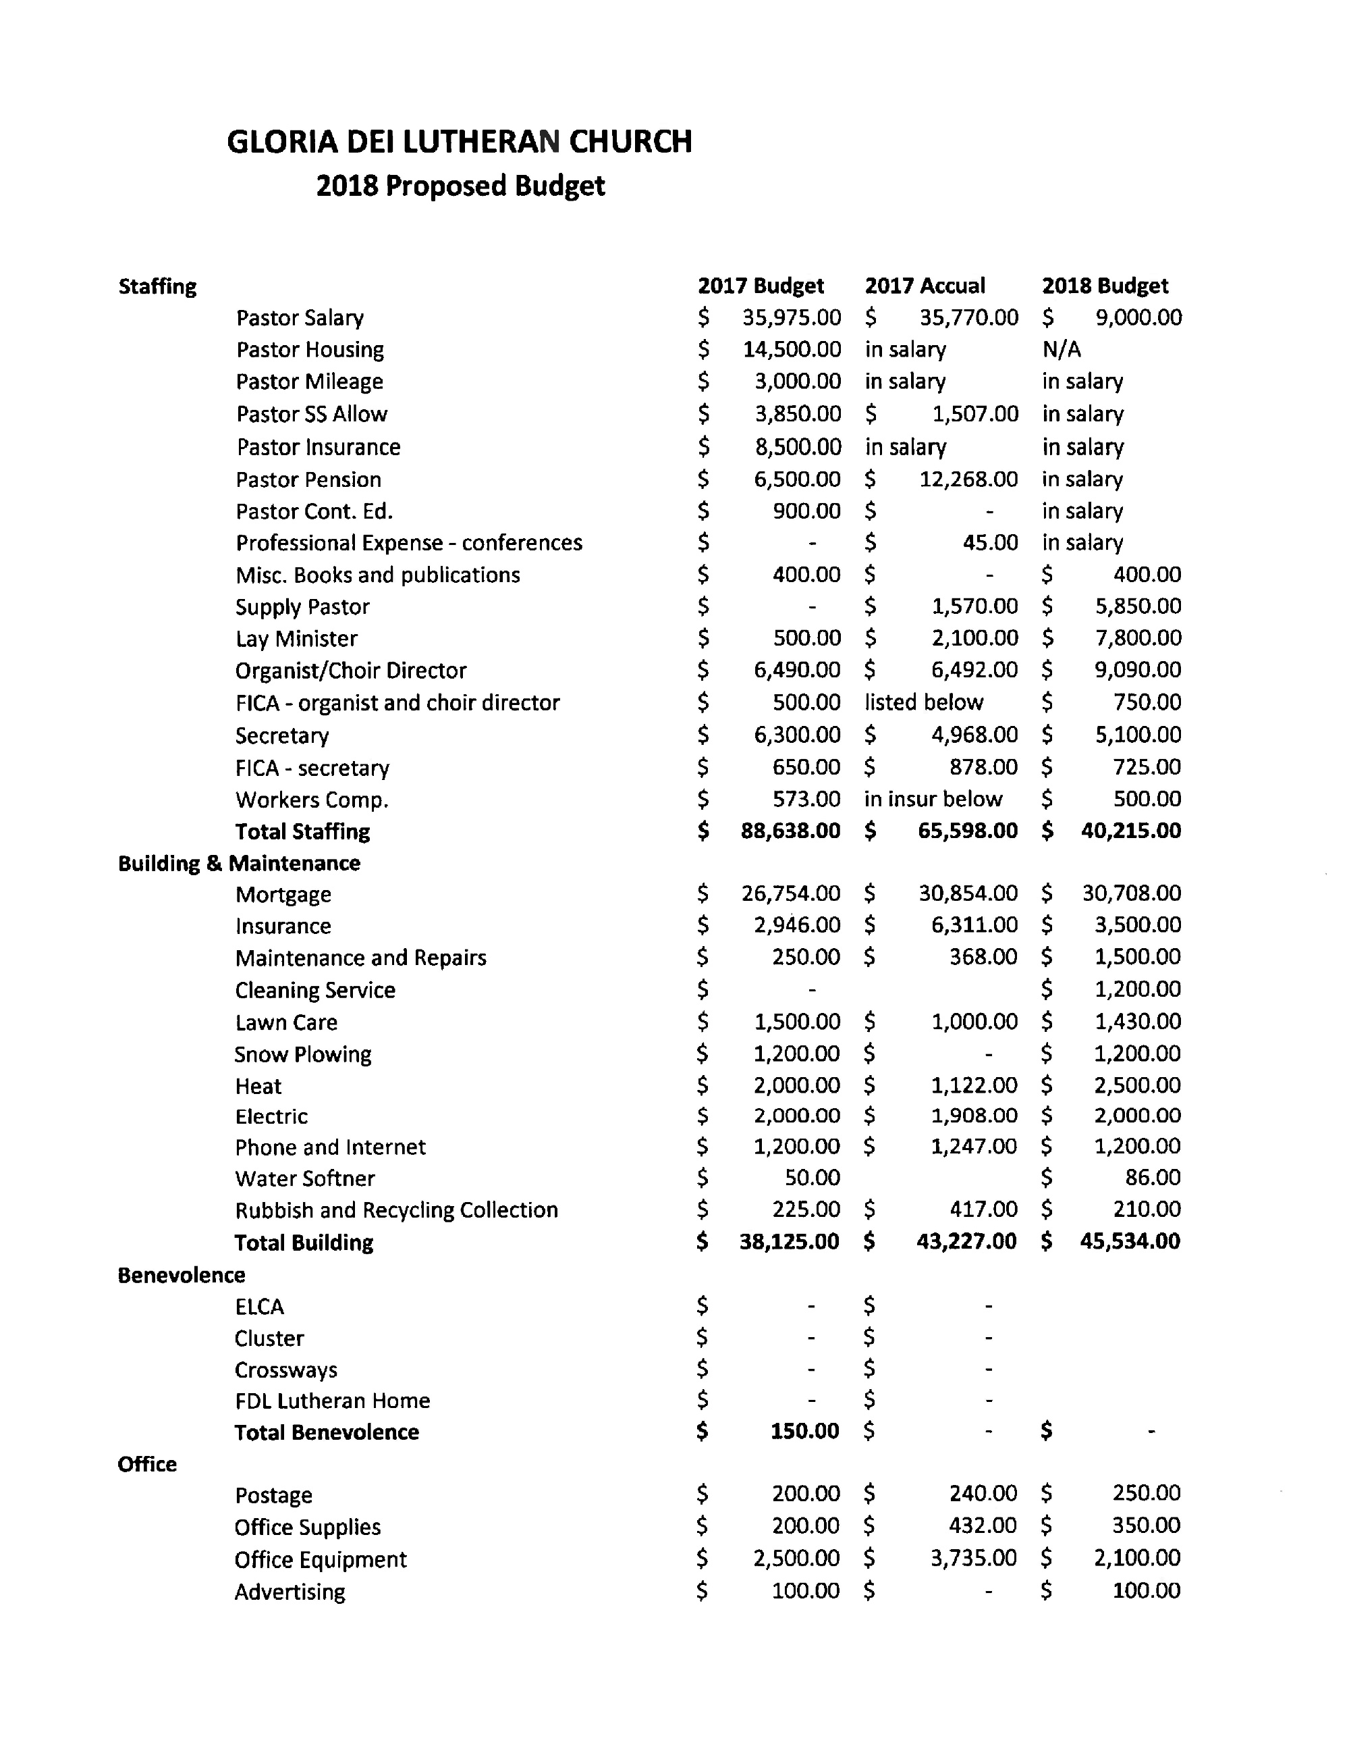

10

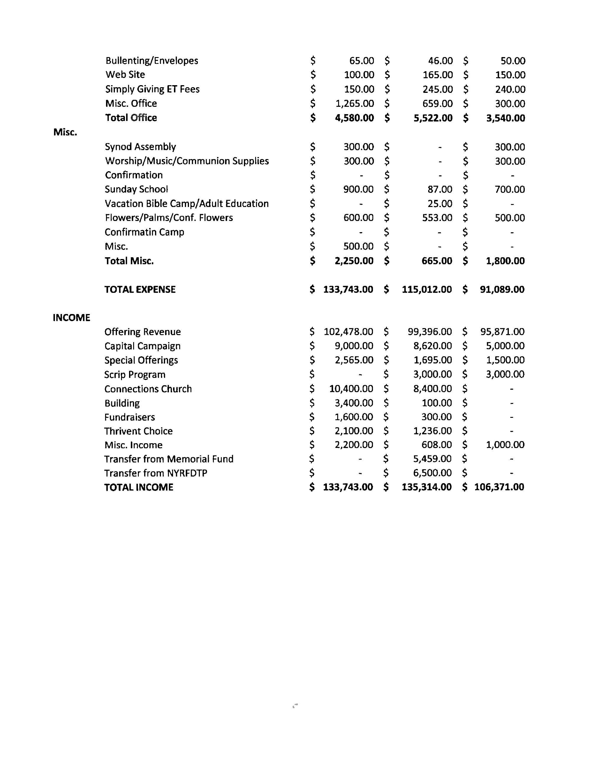

11